Lesson 06 Demo 04

Logging Analytics Workspace

Objective: To create a log analytics workspace to consolidate all your logs in one central place
Tools Required: Azure account with administrator access

Prerequisites: None

Steps to be followed:
- Create a log analytics workspace
- Connect a VM to the workspace

Step 1: Create a log analytics workspace

- Log in to the Azure Portal and search for Log Analytics workspaces

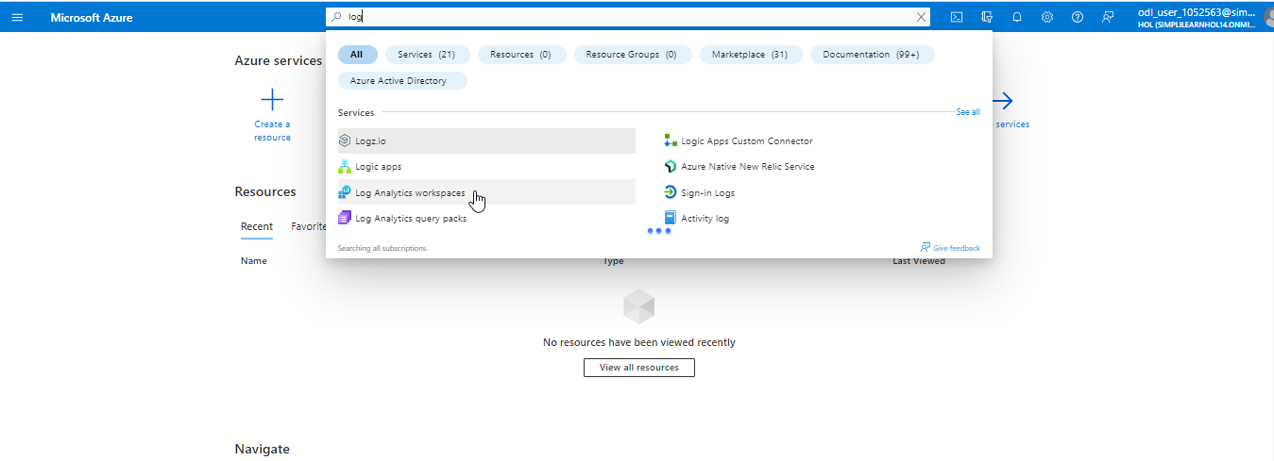

- Click on + Create

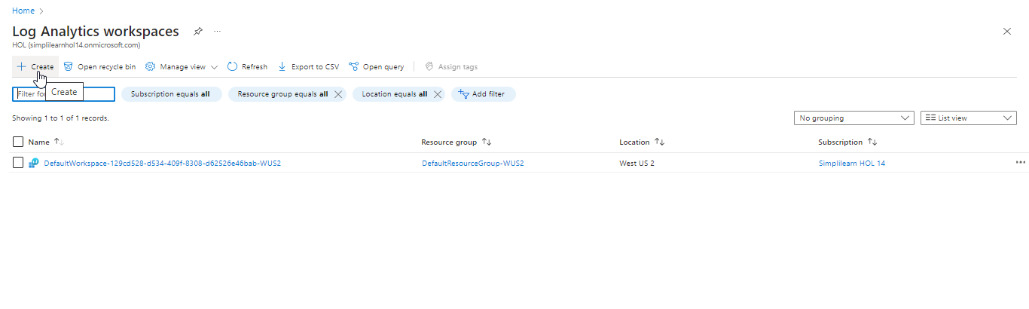

- In the Project details tab, click on Create new to create a Resource group (RG01)

- In the Instance details tab, enter Name as workspace1, and click on Review + Create.

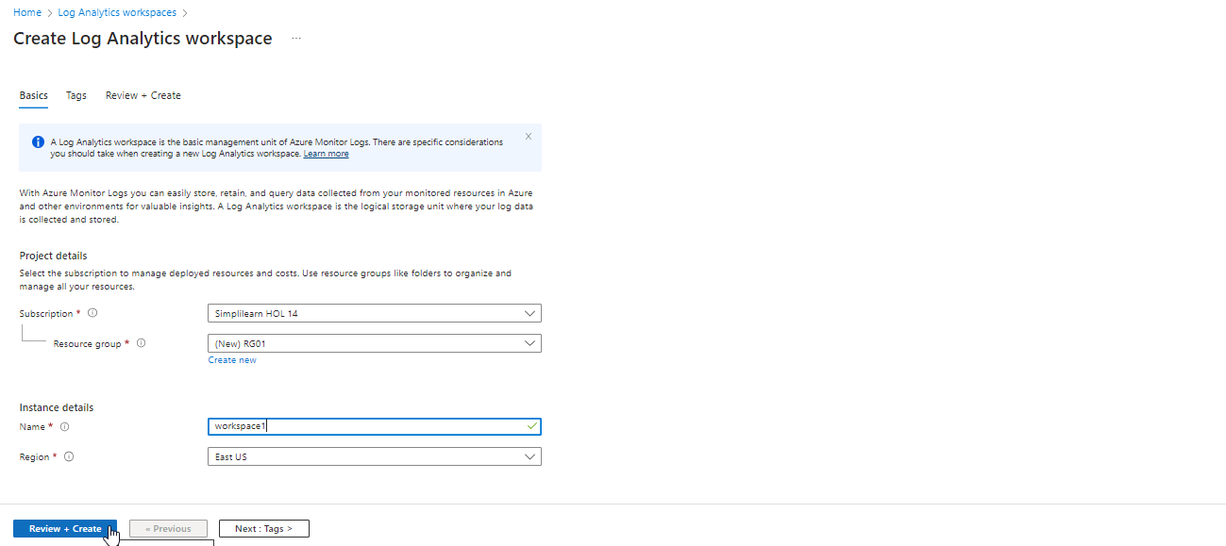

- Then, click Create

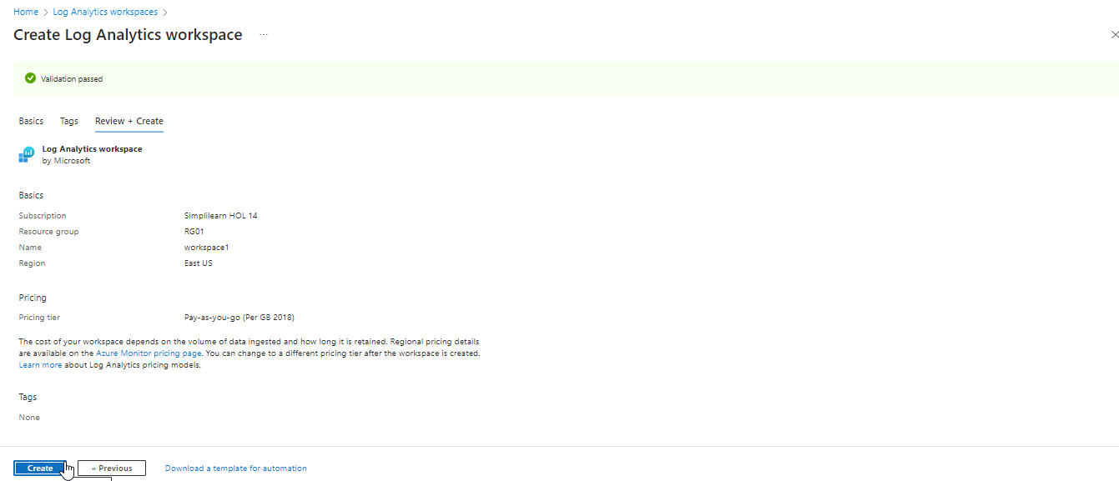

The output will appear as follows:

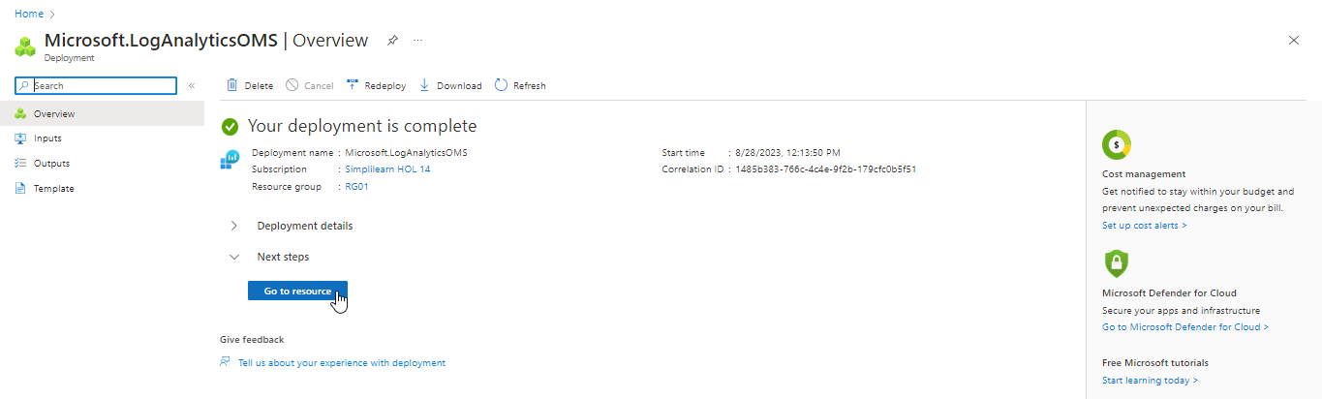

Step 2: Connect a VM to the workspace

  - Go to the Log Analytics workspaces and select workspace1

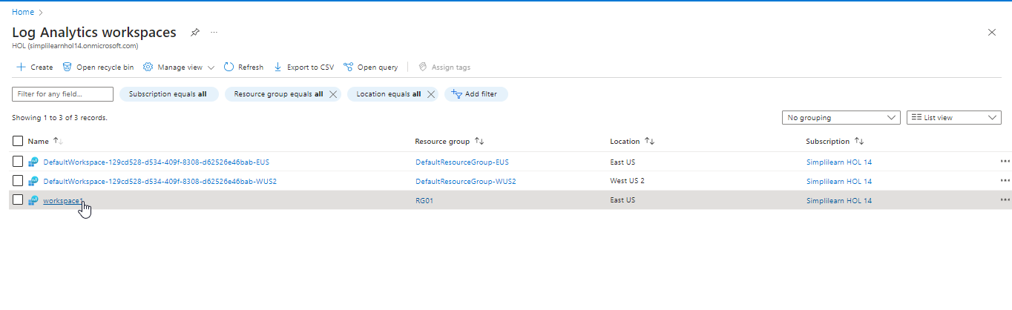

  - Select VM-1052563 under virtual machines (deprecated)

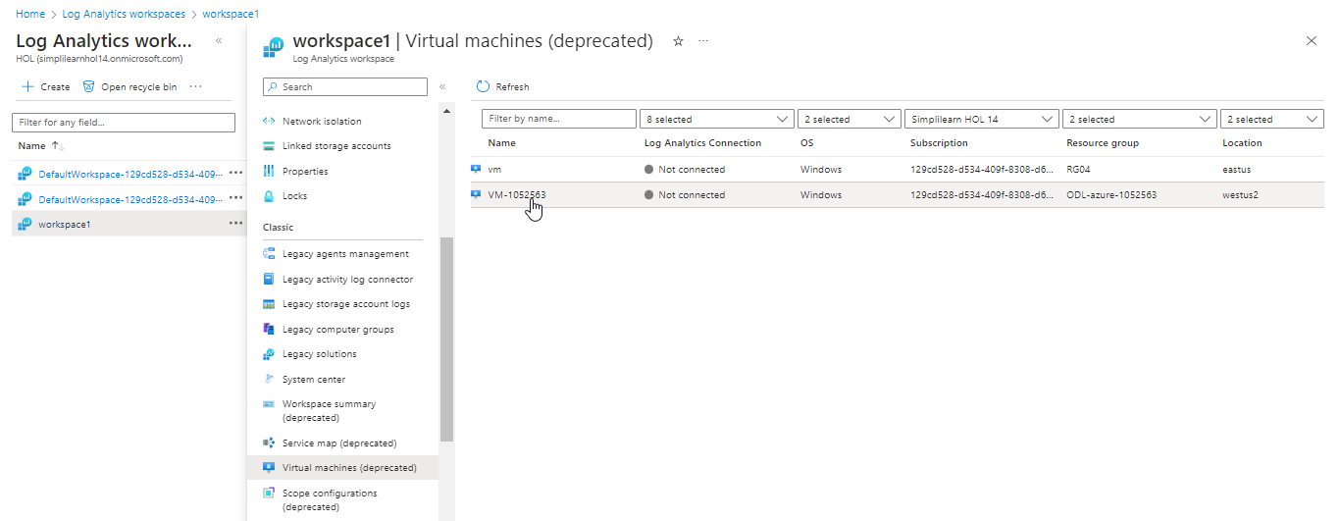

  - Then, click on Connect under VM-1052563

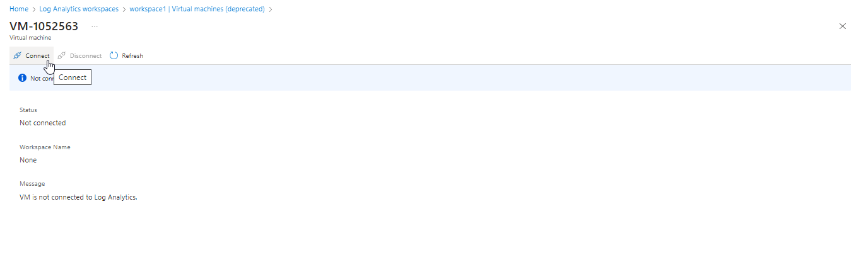

The output will appear as follows:

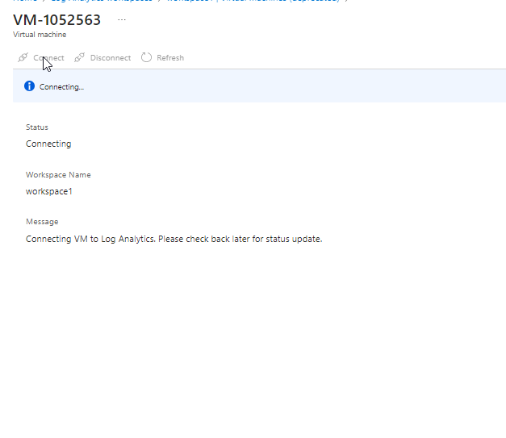

You have now successfully created and set up the log analytics workspace to consolidate all your logs in one central place.

